Module 7 – R53

Assignment 1: Creation of Amazon Route53 with Domain creation

(How to Configure Amazon Route 53?)

Below are the steps to create Amazon Route53

Step 1: Search Route53 in AWS Console search box:

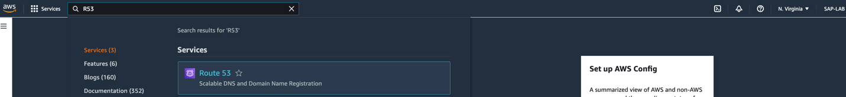

Step 2: Click on ‘Registered domains’ in left pane-

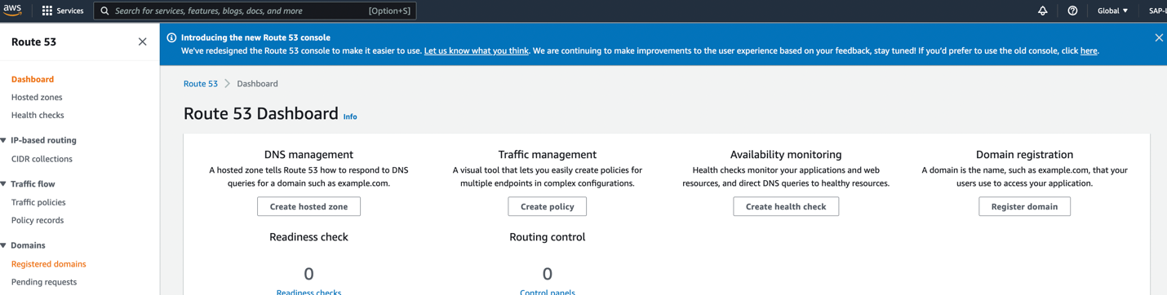

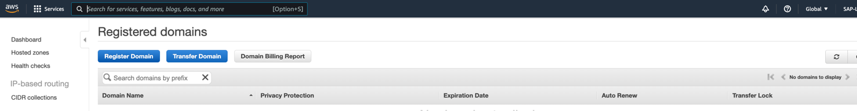

Step 3: Under Domain Search Section – put the name you wish to have for your domain eg. – educate4self. Click on **check** if this domain name will be available, it will be available to add to cart. This service is chargeable. Click on ‘**Add to cart’** and the **‘Continue’.**

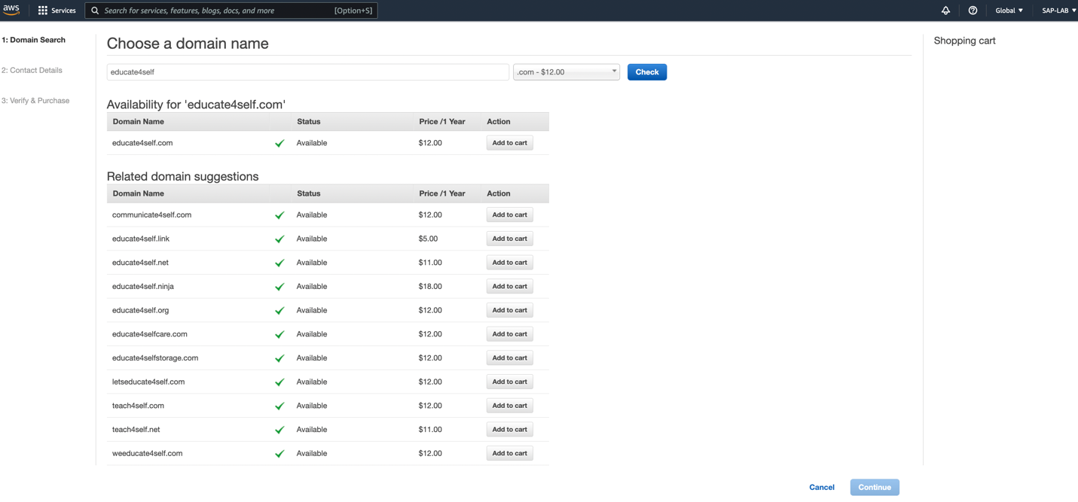

Step 4: Under **Contact Details** provide the details, and click on **continue**

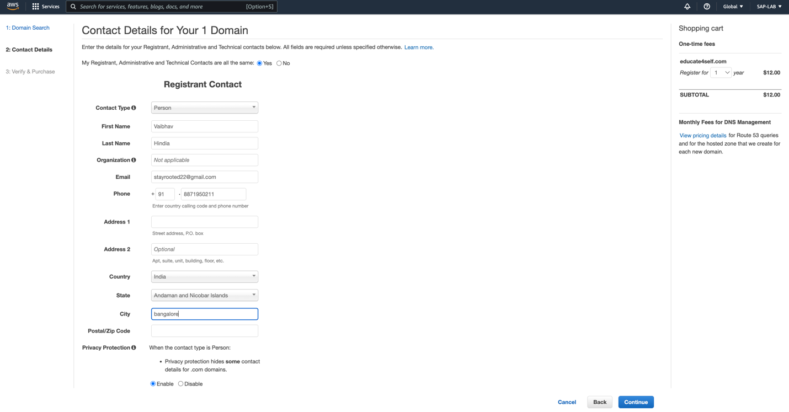

Step 5: Confirm the provided details and complete the order.

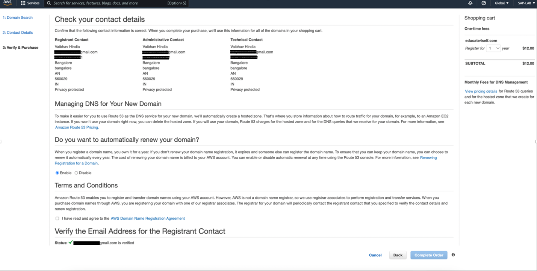

Once we get our registered domain, it will be available in left side pane under ‘Hosted zone’ which will be created by Route 53.

After you create a hosted zone for your domain, such as example.com, you create records to tell the Domain Name System (DNS) how you want traffic to be routed for that domain.

**To configure records in Route 53**

Below are the steps to create record:

Step 1: Go to Hosted zones, click on the domain name. And click on ‘create record’.

Configure below details -

1. Record name – test (put name/word anything we want before ‘educate4self.com’)
2. Record type – Select the record type to define the route traffic, we selected ‘A – Routes traffic to an IPv4 address and some AWS resources’
3. Value – value to route traffic to(eg. 11.22.33.44)
4. TTL(Seconds) – 300
5. Routing Policy – Simple routing
6. Click on ‘Create Record’.

To test go to AWS CloudShell and follow below commands.

1. Type nslookup test.educate4self.com

It will provide server IP address and under non-authoritive answer it will provide name of our record - test.educate4self.com

Address of our record – 11.22.33.44.

As this service of AWS is chargeable, we didn’t own the domain name.